NC SICKLE CELL SYNDROME PROGRAM
SEPTEMBER-OCTOBER 2026 CALENDAR OF EVENTS

Date of event: September 6, 2026
Name of event: Blood Drive
Event sponsor: Mt. Olin AME Zion Church
Time period of event: Noon- 4:00 pm
Location of event: 2583 Smyre Farm Road, Newton, NC 28658
Audience: (clients, health professionals, community members, etc.)
Contact for more information: naomi.moore@dhhs.nc.gov or Mt. Olin @ 828-464-8755



Date of event: September 18, 2026
Name of event: 2026 Tate Holbrook 5th Annual Sickle Cell Disease Update at East Carolina University (ECU)
Event sponsor: East Carolina University’s Comprehensive Sickle Cell Program
Time period of event: 8:30 am – 4:00 pm
Location of event: The Education Center at Eastern Area Health Education Center, 2600 W. Arlington Blvd., Greenville, NC 27835
Audience: (clients, health professionals, community members, etc.)
Cost: The event is free, but registration is required- To register, click here or go to: https://www.easternahec.net/courses-and-events/768563

_________________________________________________________

Date of event: September 19, 20256
Name of event: 12th Annual Carnival for a Cause
Event sponsor: ECU Comprehensive Sickle Cell Program
Time period of event: 11:00 am – 2:00 pm
Location of event: C.M. Eppes Recreation Center-Thomas Foreman Park, 400 Nash Street, Greenville, NC 27834
Audience: (clients, health professionals, community members, open to the public)
Cost: Free food, games, prizes and fun for all ages
Contact for more information: Individuals requesting accommodation under the ADA should contact the ADA coordinator at least 48 hours prior to the event at 252-737-1018/ada-coordinator@ecu.edu

Date of event: September 19, 2026
Name of event: Blood Drive
Event sponsor: Tried Stone Baptist Church
Time period of event: 10:00am-3:00pm
Location of event: 100 Carroll Avenue, Asheville, NC 28801
Audience: (clients, health professionals, community members, etc.)
Contact for more information: naomi.moore@dhhs.nc.gov or Tried Stone @ 828-285-0444

_______________________________________________________________________________________________________

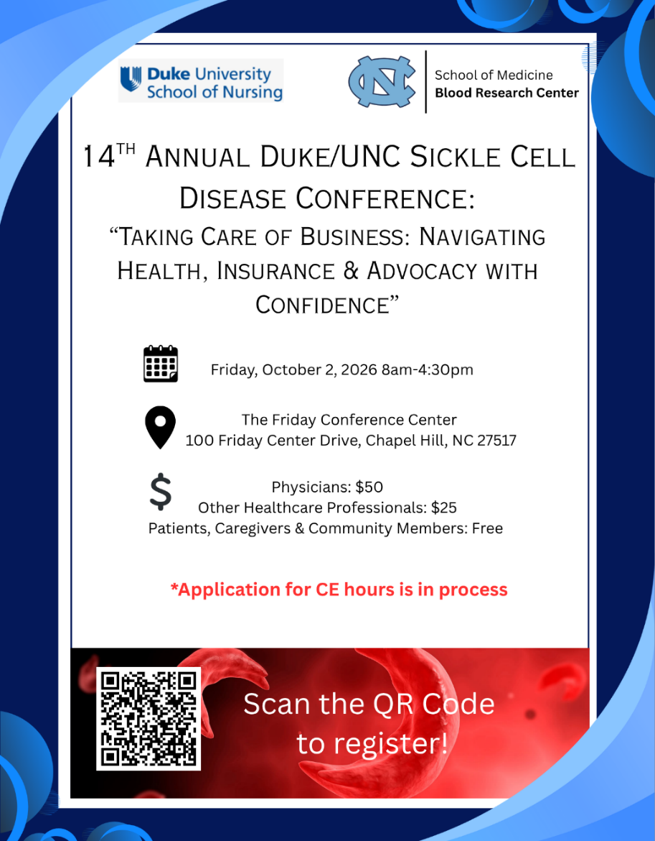
Date of event: October 10, 2026
Name of event: Sickle Cell Run/Walk
Event sponsor: Piedmont Health Services and Sickle Cell Agency
Start time of event: 9:00 am
Location of event: Honeycutt Park, 352 Devers Street, Fayetteville, NC 28303
Audience: (general public, community members, etc.)
Contact for more information: wlyons@piedmonthealthservices.org or
910-229-2393

__________________________________________________________________________________________________

Date of event: October 12, 2026
Name of event: 5th Annual 2026 Sickle on the Green Golf Tournament
Event sponsor: Sickle Cell Partners of the Carolinas
Time period of event: Registration check in 9:00 am
Location of event: NorthStone Country Club, 15801 Northstone Drive, Huntersville, NC 28078
Audience: (general public)
Register @ https://birdease.com/sickleonthegreen

