Remove the printer and supplies from the packaging. The box will contain two cardboard cores (½” and 1”) and one yellow plastic core adapter (do not discard cores or adapter).
NOTE: Printers being mailed from SLPH will also include 1 roll of 2 x 1 polyester labels and 6 rolls of thermal ribbon.

STEP 1:
- Open the printer using the yellow hinges on the sides of the printer.
- Open a roll of thermal ribbon and install on the printer by attaching the ribbon roll to the lower ribbon connection (twist to lock into grooves) then stretch the tape from the ribbon to a ½” (empty) cardboard core that you’ve added to the upper connection. Roll the connection a few times to firmly attach the ribbon to the empty core. See FIG 1 below.
- NOTE: Thermal ribbon rolls with either a ½” or 1” core can be used. We are currently using the ½” core rolls which can be installed directly onto the printer. The adapter can be used if you use a larger core size ribbon (1”).
- NOTE: When the thermal ribbon roll goes empty, save the cardboard core and use it to feed the next new roll of thermal ribbon onto.
STEP 2:
- Open the roll of 1” by 2” labels and install on the printer. See FIG 2 below.
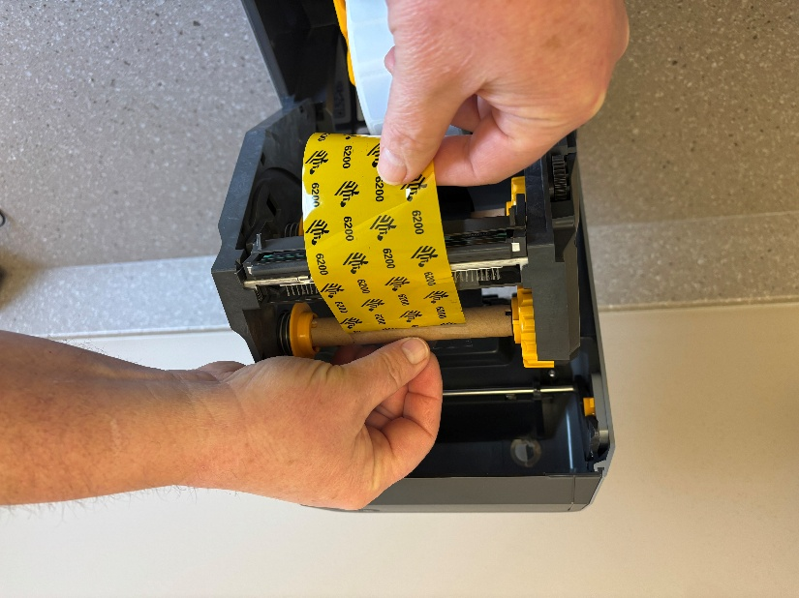  FIG 1 | 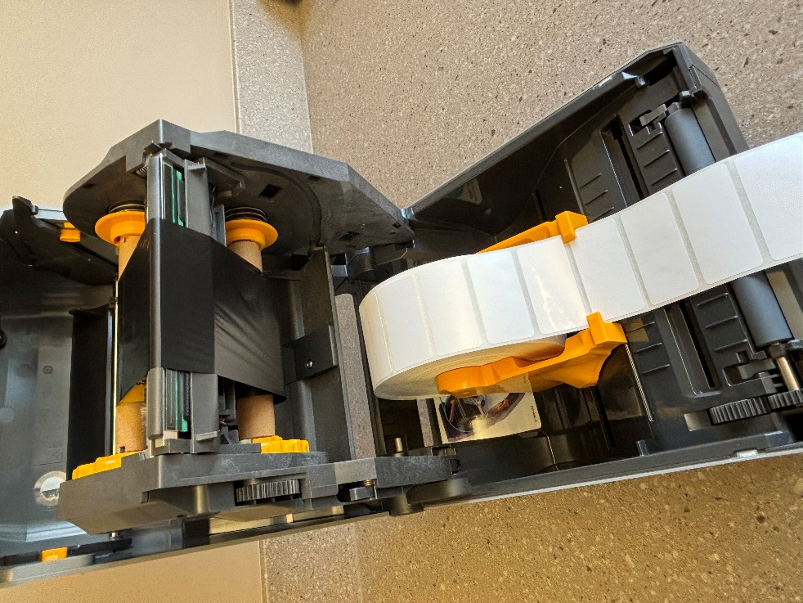  FIG 2

STEP 3 (Note this step may require your local IT support team assistance):
- Use the printer instruction manual to complete setup.
- NOTE: Before attaching the USB cable and plugging in and turning on your printer, you must first install the zebra 621t printer driver on your pc. This may require either of the following:
  - There’s a QR code card to follow or you can go to the Zebra website:
  - Support and Downloads | Zebra https://www.zebra.com/us/en/support-downloads.html
- NOTE: The 300dpi driver should be automatically detected and installed.
- After the printer driver is installed, you can finish the setup.

STEP 4:
Once the printer is setup on your pc, the label format needs to be adjusted to fit the labels.
- Click the Start icon on your PC taskbar.
- Choose Settings
- Bluetooth and Devices
- Printers and Scanners
- Choose the Zebra Printer ( ZDesigner ZD621-300dpi ZPL)
- Printing Preferences
- For Media settings set Width to 2” and Height to 1”. See FIG 3 below.

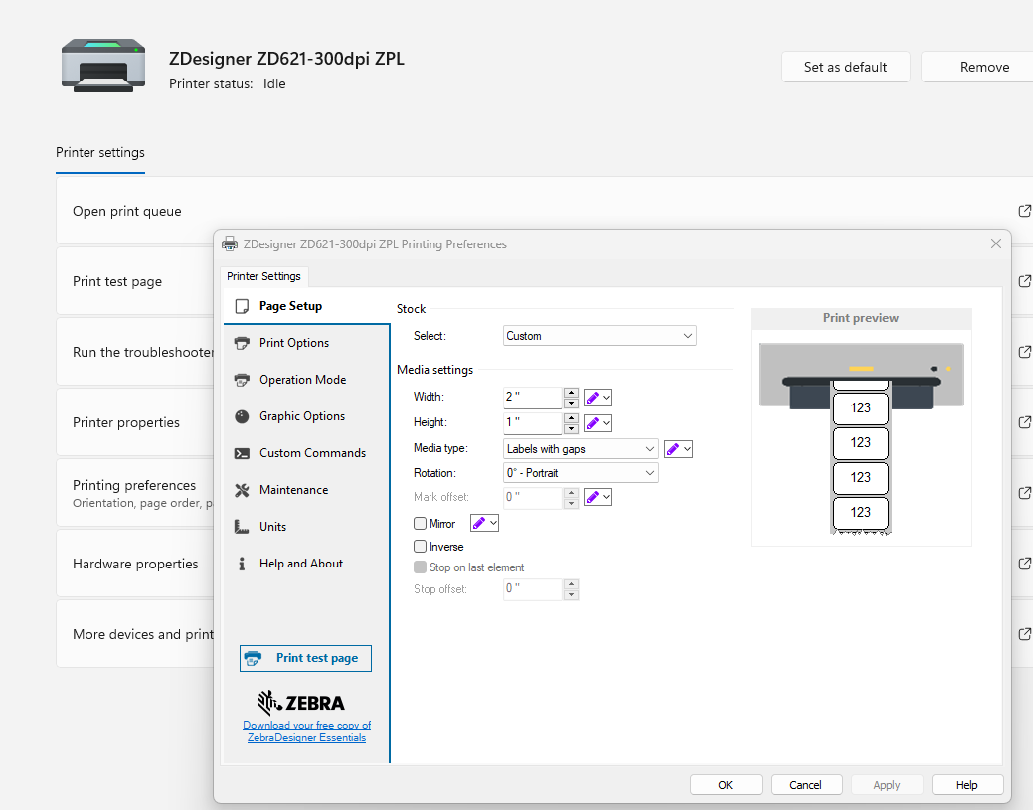
FIG3
- While in Printing Preferences, select Print Options:
- Set the Darkness to 25. See FIG 4 below.
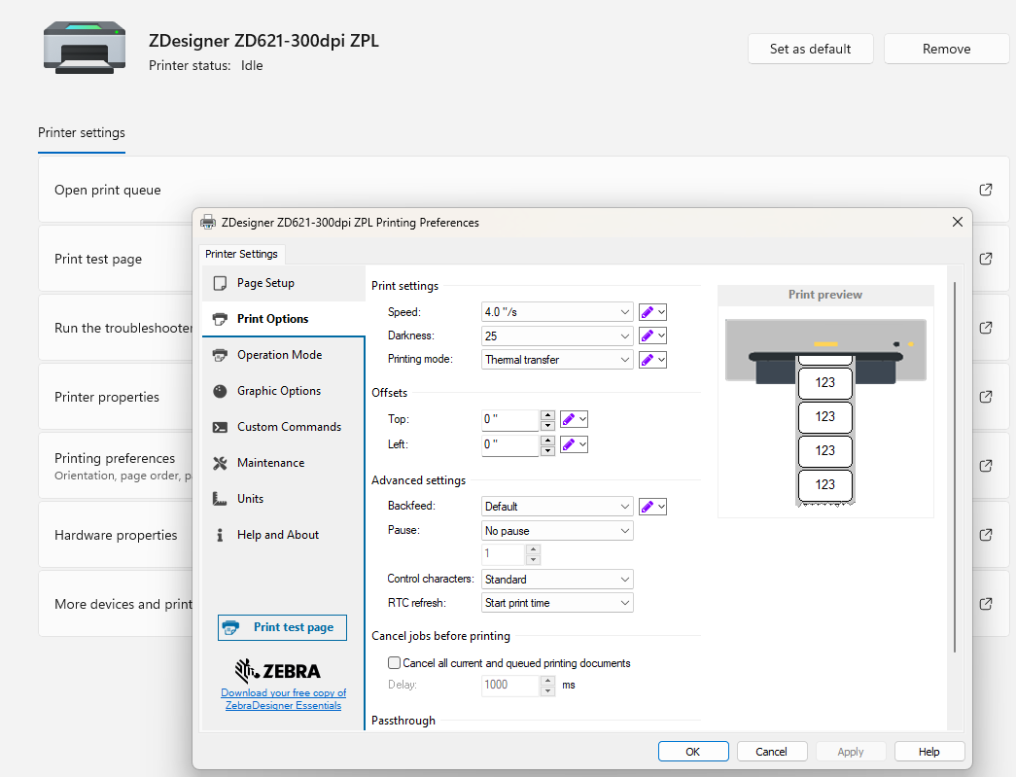
FIG 4
- Select ok to close out the window.
- When you print sample labels, you must always select Portrait as the Layout.

If you run into issues or have questions, you can contact:
Shane Pierce (NC SLPH LIMS Manager)
shane.pierce@dhhs.nc.gov

