How to Fill Out the Open Window Budget Form in Excel

Important Notes:
- Only enter information in yellow shaded cells only. Do NOT enter or delete anything in blue shaded cells.
- Numbers entered into the Amount cell must be whole dollars (no cents).
- Enter dollars and justifications that will use State/Federal Funds only. (If your contract has legally mandated local match, do not enter any dollars contributed by until the very end of the form in the Contractor Match section.)
- Budget narratives must show calculations for all budget line items and clearly justify/explain the need for these items. Budget costs must be in accordance with State rates, reasonable, and justifiable. Budget must support the Scope of Work activities and objectives.
- All expenses that are shared across multiple programs (e.g., rent, utilities, insurance, etc.) must be prorated for this program and the narrative must include a detailed calculation which demonstrates how the agency prorates the items.

Overview of Tabs:
Worksheet (Tab) 1: Contractor Budget Worksheet
Worksheet (Tab) 2: Salary and Fringe Worksheet
Worksheet (Tab) 3: Subcontractor Budget Worksheet

Worksheet (Tab) 1: Contractor Budget Worksheet
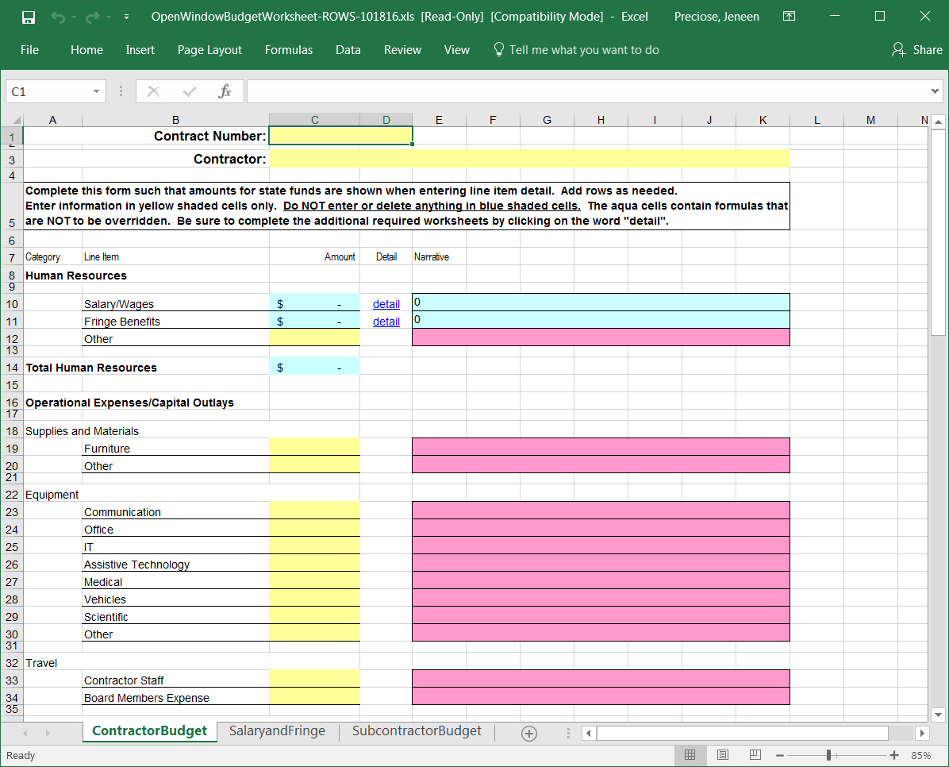

Contract Number: DPH Staff should enter the Open Window contract number assigned to the contract.

Contractor: Please insert the agency’s full Legal Name.

Human Resources:
This section should be filled out for all employees of the agency, including full-time and part-time staff. Annual values must be used – do NOT prorate any of these items. The spreadsheet will prorate for you based on the number of months and percentage of time entered for each staff.

Salary/Wages: Do not enter anything into the shaded blue boxes. Click on word “detail” to complete the required Worksheet # 2: Salary and Fringe. The information you enter into Worksheet (Tab) #2: Salary and Fringe will carry over to the Worksheet (Tab) #1: Contractors Budget. Worksheet (Tab) #1 will show a Salary Subtotal of the personnel included on the grant. See page 7 of this document for detail.

Fringe Benefits: Do not enter anything into the shaded blue boxes. Click on word “detail” to complete the required Worksheet # 2: Salary and Fringe. The information you enter into Worksheet (Tab) #2: Salary and Fringe will carry over to the Worksheet (Tab) #1: Contractors Budget. Worksheet (Tab) #1 will show a Fringe Subtotal of the personnel included on the grant. See page 8 of this document for detail.

Other: Other would be used to document payments for human resources that are outside of the Contractor’s staff but are not considered subcontractors. For example: temporary workers.

Total Human Resources: This field will automatically calculate the totals from Salary/Wages, Fringe Benefits, and other to give you the total amount for the Human Resources Category.

Operational Expenses/Capital Outlays:
Note: For all expenses that fall under the Operational Expenses/Capital Outlays Category enter to the total amount in the yellow shaded box. Then include a detail narrative in the pink shaded box to justify the total amount declared in the yellow shaded box. Budget narratives must show calculations for all budget line items and must clearly justify/explain the need for these items. All expenses that are shared across multiple programs (e.g., rent, utilities, insurance, etc.) must be prorated for this program and the narrative must include a detailed calculation which shows how the amount is prorated.

The next section will highlight, define and give examples for each line item. The examples listed below are to give you an idea of items that might be allowable per your grant. The items below are not required; they are just listed as examples. If you need clarity, please contact your Contract Administrator for additional details.

Note: Do NOT add new line items to the budget such as “Sponsored Meeting Expenses”. The line items included in the Budget reflect the budget categories in the NC DHHS online contracts system, NC DHHS Open Window. All budget expenses must fit in one of the line items listed. Please use the guidance below to place your expense in the proper budget line item.
Major Line Items are listed below in BOLD.
Subcategories of Major Line Items are listed below that item and UNDERLINED.

Supplies and Materials:
Furniture: Desks, Bookshelves, chairs, file cabinets, etc.
Other: Additional Supplies and Materials purchased such as Educational items, Curriculums, Videos, Books, Training manuals, Office supplies, Postage, Business cards, etc. Stand alone, purchased software, under $500 (such as Peachtree Accounting or similar) is also considered a supply. Disposable (one-time-use) medical supplies are also considered a supply.
Justification Sample: Routine office supplies: $50 per person per month (2 staff members @ $50 x 12 = $1,200).
2 cartridges for laser printer @ $50 = $100.

Equipment: Equipment is for items that are purchased outright – not rented or leased. Typically, an item considered “Equipment” is a depreciable asset.
Communication: Telephone System. Note: this is not monthly usage, but rather the initial purchase of these items. Monthly usage should be entered under Utilities.
Office: Copier Machine, Fax Machine.
IT: Personal Computers, laptops, iPads, scanners, desk printers, PC speakers.
Assistive Technology: Assistive, adaptive and rehabilitative devices for people with disabilities examples: hearing aids.
Medical: Wheelchairs, stethoscopes, blood pressure machines, EKG monitors. This is durable equipment purchased for long-term use.
Vehicles: A vehicle that is purchased for program use. Note: Certain grants may not exceed $2,000 per item.
Scientific: Centrifuge, Microscope, Lab equipment.
Other: Use this for any equipment item that does not fit in one of the defined categories above.
Justification Sample for IT Equipment: Desktop Computer: 2 Computers @ $500 each for the Program Manager and Coordinator to use for writing reports, capture data, and entering data into online database = $1,000; 2 laser printers @ $150 each for the Program Manager and Coordinator to print reports, materials, program policies, etc. = $300.

Travel:

Contractor Staff: Include any travels, meals, mileage for staff members listed under the salary and fringe section.
Board Members Expense: Includes any travel, meals, mileage for board members or community partners.
Justification Sample for Contractor Staff Travel: Overnight accommodations for Program Coordinator and Program Assistant to attend required XYZ Training: 2 nights x $110.00 = $220.00. 418 miles round trip from Greensboro, NC to Wilmington, NC for training x $0.725/mile = $303.50. 2 staff x (1 breakfast at $16.00 each + 2 lunches at $19.00 each + 2 dinners at $28.00 each) = $220.00. Total travel: $220.00 + $303.50 + $220.00 = $743.05.

Travel Reimbursement Rates:
Mileage reimbursement rates must be based on rates determined by the North Carolina Office of State Budget and Management (OSBM). Because mileage rates fluctuate with the price of fuel, the OSBM will release the “Change in IRS Mileage Rate” memorandum to be found on OSBM’s website when there is a change in this rate. The current state mileage reimbursement rate is $0.725 cents per mile (updated January 1, 2026).

For other travel related expenses, please refer to the current rates for travel and lodging reimbursement, presented in the chart below. However, please be advised that reimbursement rates periodically change. The Division of Public Health will only reimburse for rates authorized in North Carolina Department of Health and Human Services Travel Policy. Effective July 1, 2021, the Department of Health and Human Services (DHHS) shall utilize GSA State/City Standard Travel Per Diems as the maximum allowable statutory rate for meals and lodging (subsistence). The following schedule shall be used for reporting allowable subsistence expenses incurred while traveling on official state business:

Current Rates for Travel and Lodging
Meals | In State | Out of State
Breakfast | $16.00 | $16.00
Lunch | $19.00 | $19.00
Dinner | $28.00 | $28.00
Total Meals Per Diem Per Day | $63.00 | $63.00
Lodging (Maximum rate per person, plus taxes and fees) | $110.00 + taxes/fees | $110.00 + taxes/fees
Total Travel Allowance Per Day | $173.00 | $173.00
Mileage | $0.725 per mile/regardless of distance

Utilities: (If not included in the rent)
Gas: Monthly Gas bill prorated for program share
Electric: Monthly Electricity bill prorated for program share
Telephone: Monthly Phone or Cell service prorated for program share
Water: Monthly Water bill prorated for program share
Other: Use this for any utility item that does not fit in one of the defined categories above, such as internet service (unless combines with telephone), security monthly monitoring cost, etc.
Justification Sample: Prorated share of electric bill: 25% of $100 monthly cost; 12 months x $25 = $300.

Repair and Maintenance: Custodial Services or basic Repairs and Maintenance not billed in the Professional Service area.
Justification Sample: Custodial Services for services and maintenance of space used by programs and Program Coordinator's office @ 12 months x $65 = $780.

Staff Development: Conference, Workshops, Continuing Education for Contractor staff.
Justification Sample: Quarterly training costs for staff: 2 staff x $75 per class x 4 classes = $600.

Media/Communications:
Advertising: Newspaper, Billboard, etc. Can be ads for program or staff recruitment.
Audiovisual Presentations, Multimedia, TV, Radio Presentations: Development of PowerPoint presentations, YouTube video productions, TV and/or Radio spots.
Logos: Cost associated to create a program logo.
Promotional Items: Any giveaway items used to promote program to the general public, e.g.: keychains, t-shirts, mugs. (Items purchased as incentives for program participants belong in the Incentives & Participants category, under Other.)
Publications: Items that the Contractor is responsible for designing and producing or printing such as brochures, posters, fact sheets, etc.
PSAs and Ads: Placement costs for Public Service Announcements or Ads for television and/or radio.
Reprints: Duplication of an existing publication; photocopies.
Text Translation: Cost associated with translation of documents into another language.
Websites and Web Materials: Costs to create website, maintain website, etc.
Justification Sample for Reprints: Program flyers for community program (1000 @ $.10 = $100); photocopies for use in program sessions (400/month @ $.05 = $240).

Rent:
Office Space: Office Space, Program Meeting Space – must include square footage. Calculations must define totals and prorated amounts for the program.
Equipment: This category is for equipment that is rented or leased, such as a Copier Machine or Phone System.
Furniture: Rented or Leased office furniture.
Vehicles: Long-term leases of Cars, Vans or Buses. (Vehicles rented for short-term staff travel belong under Contractor Staff travel. Vehicles rented for short-term participant travel belong under Incentives and Participants.)
Other: Use this for any rented or leased item that does not fit in one of the defined categories above that is necessary per the grant deliverables.
Justification Sample for Office Space Rent: Example 1: Prorated rent: 25% of $1,600 monthly rent (1200 sq.ft.): 12 months @ $400 = $4,800.
Sample 2: Square feet rented: 3,000 @ $10/sq ft. = $30,000. Prorated share: 25% = $7,500).

Professional Services: These are services that are purchased to support the overhead of the agency.
Legal: Legal services retained by the Contractor
IT: Information Technology or IT-related technical services retained by the Contractor
Accounting: Accounting, bookkeeping services retained by the Contractor
Payroll: Payroll services retained by the Contractor
Security: Security services, in the form of personnel such as a security guard, retained by the Contractor. (Purchase of a security system belongs under Equipment - Other. Monthly security monitoring belongs under Utilities – Other.)
Justification Sample for Accounting: 8 hours per month at $40/hour budgeted for program accounting work such as generating financial reports, reimbursement requests, accounts payable, etc. 8 hours x $40 x 12 months = $3,840.

Dues and Subscriptions: Dues for professional associations/affiliations; Subscriptions to related or required periodicals; Subscriptions to web-based applications such as Survey Monkey or Constant Contact that are leased at a rate per month.
Justification Sample for Dues and Subscriptions: 1 Organizational Membership to Healthy Teen Network x $250 = $250.

Other:
Audit Services: Cost associated with annual financial audits preformed. NOTE: Contractors must be a Level 3 Contractor with the State (i.e., receive more than $500,000 in State dollars) for audit costs to be allowable in their budget. Audit costs are NOT allowable at all in Purchase of Service (POS) contracts.
Service Payments: Costs associated with a retained service, or medical activity such as the processing of blood work by a lab, physical examination, or the monitoring of a person's blood pressure where the practitioner is paid for the particular service rendered, rather than receiving a salary or hourly rate.
Incentives and Participants: Costs associated with: Incentives given to participants or comparison group members (e.g., gift cards, meals, diaper bags, etc.); Participant Costs (field trips, enrichment activities, etc.); Open Houses; Parents’ Nights, etc.
Insurance and Bonding: Liability Insurance to cover staff and participants while field trip or daily activities.
Other: Use this for any item that does not fit in any other category.
Note: Per NC DHHS Master Agreement with UNC System Schools, Tuition for Graduate Students in the UNC network belongs in this category.
Justification Sample for Incentives & Participants: Backpacks for 100 participants at $8.00 each = $800.

Total Operational Expenses/Capital Outlays: This field will automatically calculate the totals from everything included under the Operational Expenses/Capital Outlays to give you the total amount for the Operational Expenses/Capital Outlays Category.

Reminder: Only enter information in yellow shaded cells only. Do NOT enter or delete anything in blue shaded cells.

Subcontracting and Grants: Use this tab When the Contractor is subcontracting out the program work to another entity. Note: do not include any Professional Services (legal, accounting) as they are captured in the “Professional Services” category listed above.
Examples:
The Contractor is giving a portion of the funds to another entity who will also render services to participants such as providing education.
The contract is for an evaluation and the building of a database to track recipients of service, number of services received, etc. The Contractor hires an IT vendor to build the database. In this instance, the IT vendor is a subcontractor because the work is program related.

The information you enter into Worksheet (Tab) #3: Subcontractor Budget will carry over to the Worksheet (Tab) #1: Contractors Budget.

Indirect Cost: If allowable, enter the total amount of Indirect Cost requested in the yellow box. Indirect cost must follow Federal Grant guidelines and 2 CFR 200 Federal Uniform Guidance when funds are federal financial assistance dollars, and DPH program restrictions when funds are federal purchase of service or state dollars. In the pink area, please justify what is designated an indirect cost per this grant.

For assistance determining the allowable indirect cost rate, please use the Indirect Cost Decision Trees and the DPH FA Indirect Cost Worksheet posted on the DPH Contracts Forms website.

Contractor Match: This is the only entry in the budget that should account for mandated local match dollars. Currently, the only mandated local match contracts in DPH are Teen Pregnancy Prevention Initiatives (TPPI) APP and APPP programs and the NC DHHS Competitive Grant Program for
State-wide Health and Human Services Initiatives (NPRFA).

Enter the total amount of local match required per grant (e.g., Adolescent Parenting Program = $14,000, Adolescent Pregnancy Prevention Program = $25,000, NPRFA = 15% of grant total) in the yellow box. Then detail the complete cost narrative and calculations for all local match funds in the pink justification area.

Total Budget Expenditures: The field will automatically tabulate the subtotals and register the total amount.

Worksheet (Tab) 2: Salary and Fringe
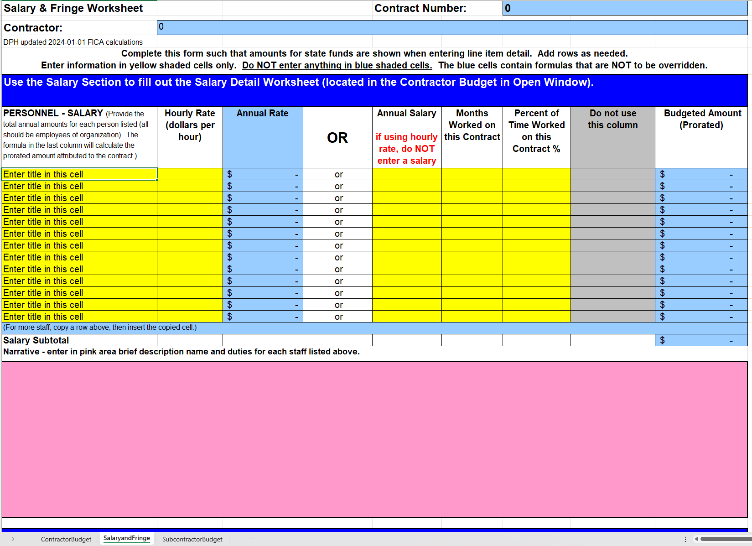

Note: Only enter information in yellow, pink or white shaded cells box. Do NOT enter or delete anything in blue shaded cells – these cells contain formulas.

Contract Number: This information will carry over from Worksheet (tab) 1: Contractor Budget

Contractor: This information will carry over from Worksheet (tab) 1: Contractor Budget

Personnel-Salary
Personnel Salary: Provide the Name and Position Title for each staff.

Personnel salary may be entered as an Hourly Rate or Annual Salary – depending on how the position is designated by the Contractor.

Option A: Hourly Rate: Dollars per hour
Months Worked on this Contract: Enter Number of months covered under contract example: 12
Percent of Time Worked on this Contract: Enter a percentage of time example: 50%
Annual Rate: Will calculate for you. Do not enter anything into this box.

OR

Option B: Annual Salary: Enter the full annual salary of each staff person.
Months Worked on this Contract: Enter Number of months covered under contract example: 12
Percent of Time Worked on this Contract: Enter a percentage of time example: 50%

Budgeted Amounts State Funds: This blue field will automatically calculate for you.

Salary Subtotal: This blue field will automatically calculate for you.

Pink Narrative Box: Provide justification of all personnel including staff names, titles and descriptions of job duties as they relate to the program. Note: Narratives for staff in contracts with any State (UNC) Universities MUST include the staff person’s university employment status as SPA, EPA, EPA Physician, etc.

Narrative Sample for Staff: Mary Jones, Program Manager – Supervises the Program Coordinators, provides oversight to program activities, generates activity reports and contributes to financial reports.

Personnel-Fringe Benefits
Personnel Name and Titles: Will carry down from the Salary/Hourly Rate field, above.

Enter the percent of salary or method of calculating each fringe benefit in the following cells: Retirement/401K, Health/Medical, Unemployment Insurance, Worker’s Comp Insurance, and other. List each benefit and include percentage for each.

FICA is calculated automatically with a formula embedded in the spreadsheet. Current FICA calculations are 6.2% in Social Security up to $184,500 in salary (effective 1/1/26) and 1.45% in Medicare with no limit.

In each yellow cell, enter the total ANNUAL fringe rates for each staff. Do NOT prorate the fringe amounts in the yellow cells. The final column (in blue) will prorate these amounts based on the number of months and percent of time worked on this contract.

Fringe Subtotal: This blue field will automatically calculate for you.

Pink Narrative Box: Provide justification narrative for fringe (i.e., explaining what “Other” is and how it is calculated).

UNC System Schools must follow the current UNC Fringe rates negotiated between UNC and NC DHHS. A copy of the current rate sheet is posted to the DPH Contracts Forms website.

Narrative Sample for Fringe*: FICA at 7.65%; Retirement at 5% (only applies to Program Manager); Unemployment at 2% and Other at 3% (includes life insurance, AD&D and liability insurance). Health insurance is calculated based on the individual.
*Note: Some programs are required to show individual calculations per staff.
Worksheet (Tab) 3: Subcontractor Budget
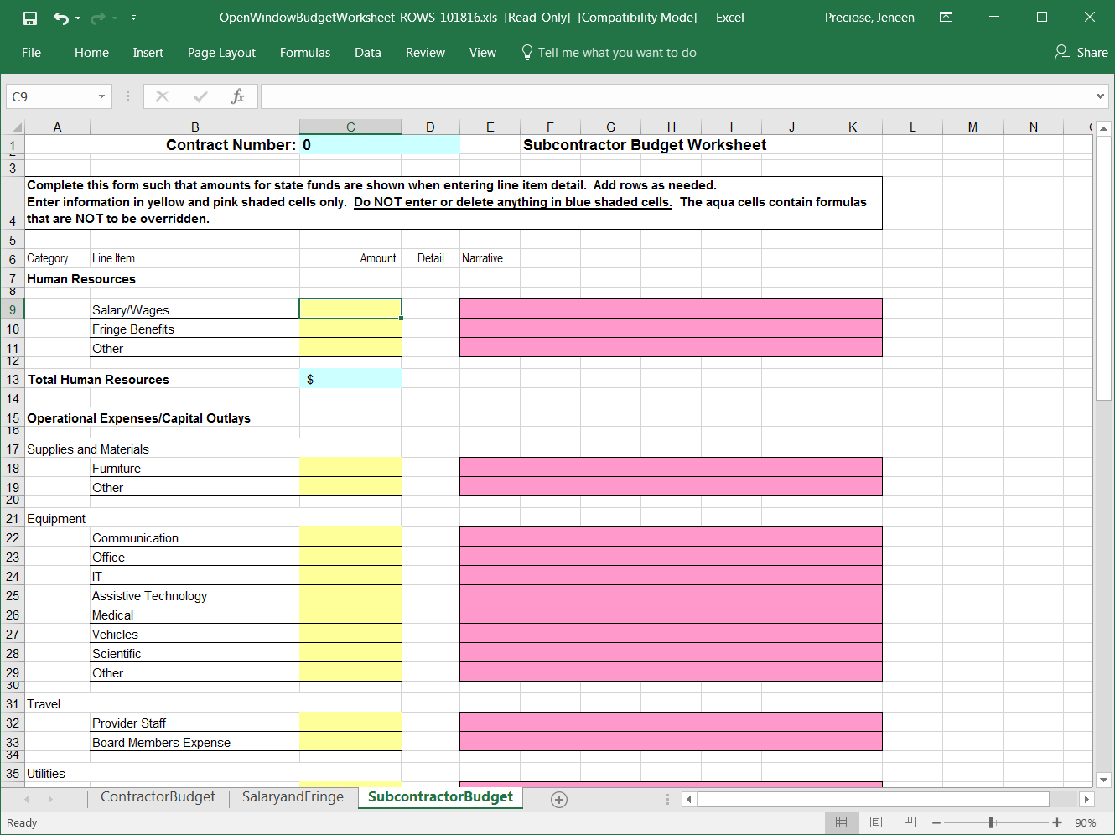

Note: Only enter information in yellow, pink or white shaded cells box. Do NOT enter or delete anything in blue shaded cells.

Enter all budget information for Subcontractor(s) used by the Contractor. Subcontractors are agencies or individuals who are contracted (by the Grantee) to perform program-related direct services. All Subcontractors must be named in the budget narrative.

Do not enter items such as Bookkeeper, Auditing, Legal Services, etc. under “Subcontractor”. These items should be entered under the “Professional Services” section of Tab 1.

All budget items must follow the same guidelines for each line item as previously outlined. The Justification for each line item must spell out exactly how much is going to which Subcontractor at what rate.

Subcontractor Salary Justification Samples:

Sally Jones will serve as the Peer Youth Trainer, she will prepare materials and deliver the curriculum: $40 per hour for 2 hours a week for 32 weeks = $2,560.

ABC Babysitting Services will provide licensed, insured childcare workers for these sessions: $15 per hour x 2 childcare workers x 2 hours x 32 weeks = $1,920. Total = $4,480.

There is only one tab for all the Subcontractors. Where more than one Subcontractor exists, each line item must be subtotaled by Subcontractor.

For example, where there are three (3) Subcontractors and they all require supplies, the Supplies Other line should read as:

ABC Health Department: office supplies for 1 staff at $20/mo. x 12 months = $240.
XYZ Community Agency: Two (2) copies of “Ready to Learn” curriculum at $135 each = $170.
LMN Department of Social Services: 1 toner cartridge at $70, 2 reams of copy paper at $12 each = 24. Subtotal = $94.
Total Subcontractor Supplies $240 + $170 + $94 = $504.

The total of $504 should be entered in the yellow box for Supplies and Materials Other line.

BEFORE YOU PRINT:

Make sure to print a sample to proofread prior to submitting your budget. It is advisable to run a spell check on all tabs and proofread each worksheet to eliminate spelling and grammatical errors. It will also be helpful to have a staff member (who is not involved with creating the budget) look it over for clarity and use an adding machine or calculator to verify the arithmetic in the budget – especially in the justification narratives where calculations are not based on formulas. Errors in the budget document will create delays in contract review and execution.

Some rows may need to be expanded if a lot of text has been entered (e.g. the rows that contain justification narrative). Print all worksheets that contain information so it can be proofread off-screen. Be sure to look at your printout carefully and go back and expand the row as needed to ensure that all the text entered in the cell is visible. To expand the row, click the row so it’s highlighted, then move your cursor toward the bottom of the row until you see this boundary symbolô, then drag the boundary down until the row is the height that you want.

For long justification narratives, you may need to do more than expand the cells. After a certain character limit, Excel will not auto-wrap cell contents and you may need to manually enter a hard carriage return. To do this in Excel, press the keys Alt + Enter at the end of each line. Excel moves to the next line—but not the next cell. You will likely then need to expand the height of your cell to include all the text entered.

Expanding the cells and entering manual returns where needed allows the reviewers to view all the details included in the pink justification field. Neither the Contract Administrator nor NC DPH staff will be held responsible for any information hidden within the cells.

Be sure to save your revisions.

